Lab 1: Create a database name “College” and within it define a table name “students” with the following attributes:

Student id

First name

Last name

Date of birth

GPA

Write the SQL statement to complete this task, including the appropriate data types for each attribute.

Solution:-

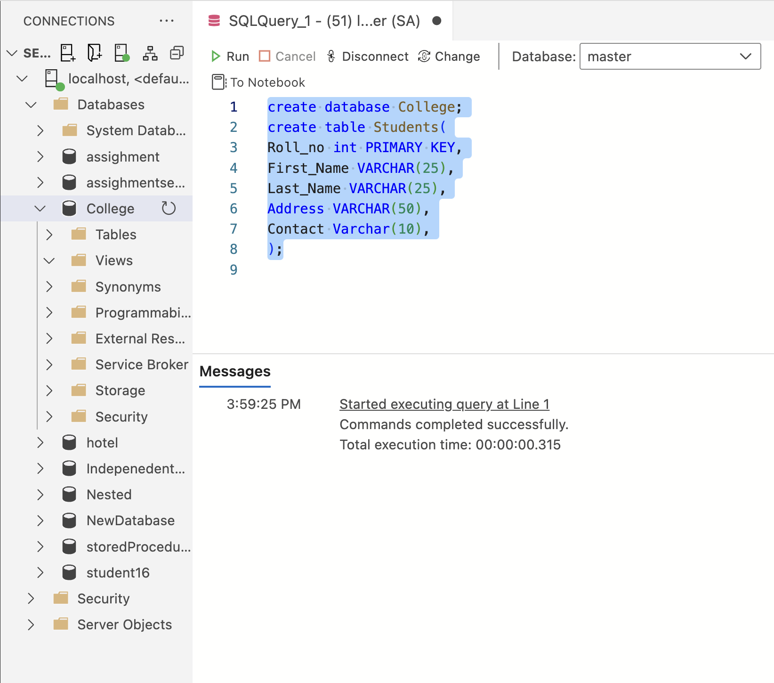

Lab 2:

Create a collage database, consisting student table with following

information.

• Roll no(int)

• Name (first name and last name ) varchar (50)

• Address varchar (50)

• Contact varchar (10)

1.Create a student table.

Solution:-

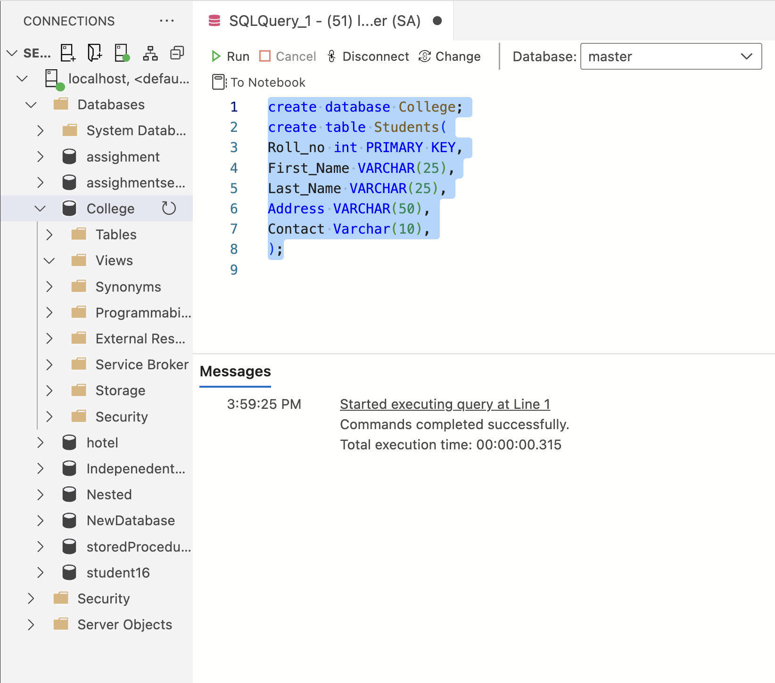

2.Insert any 5 records to the student table.

Solution:-

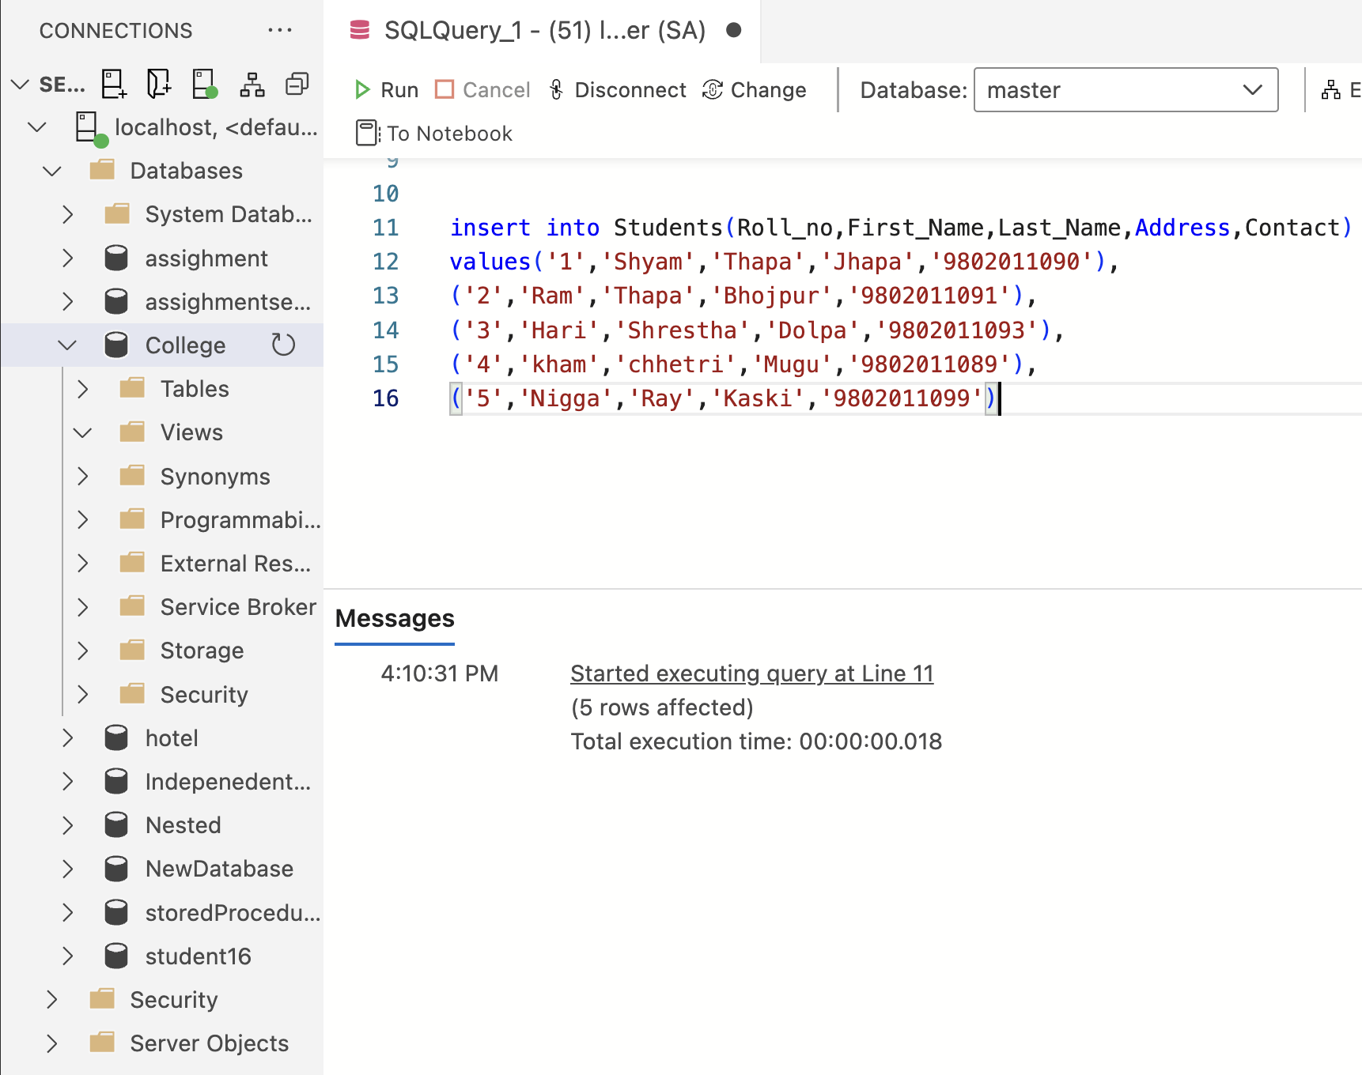

3.Display all records of student table.

Solution:-

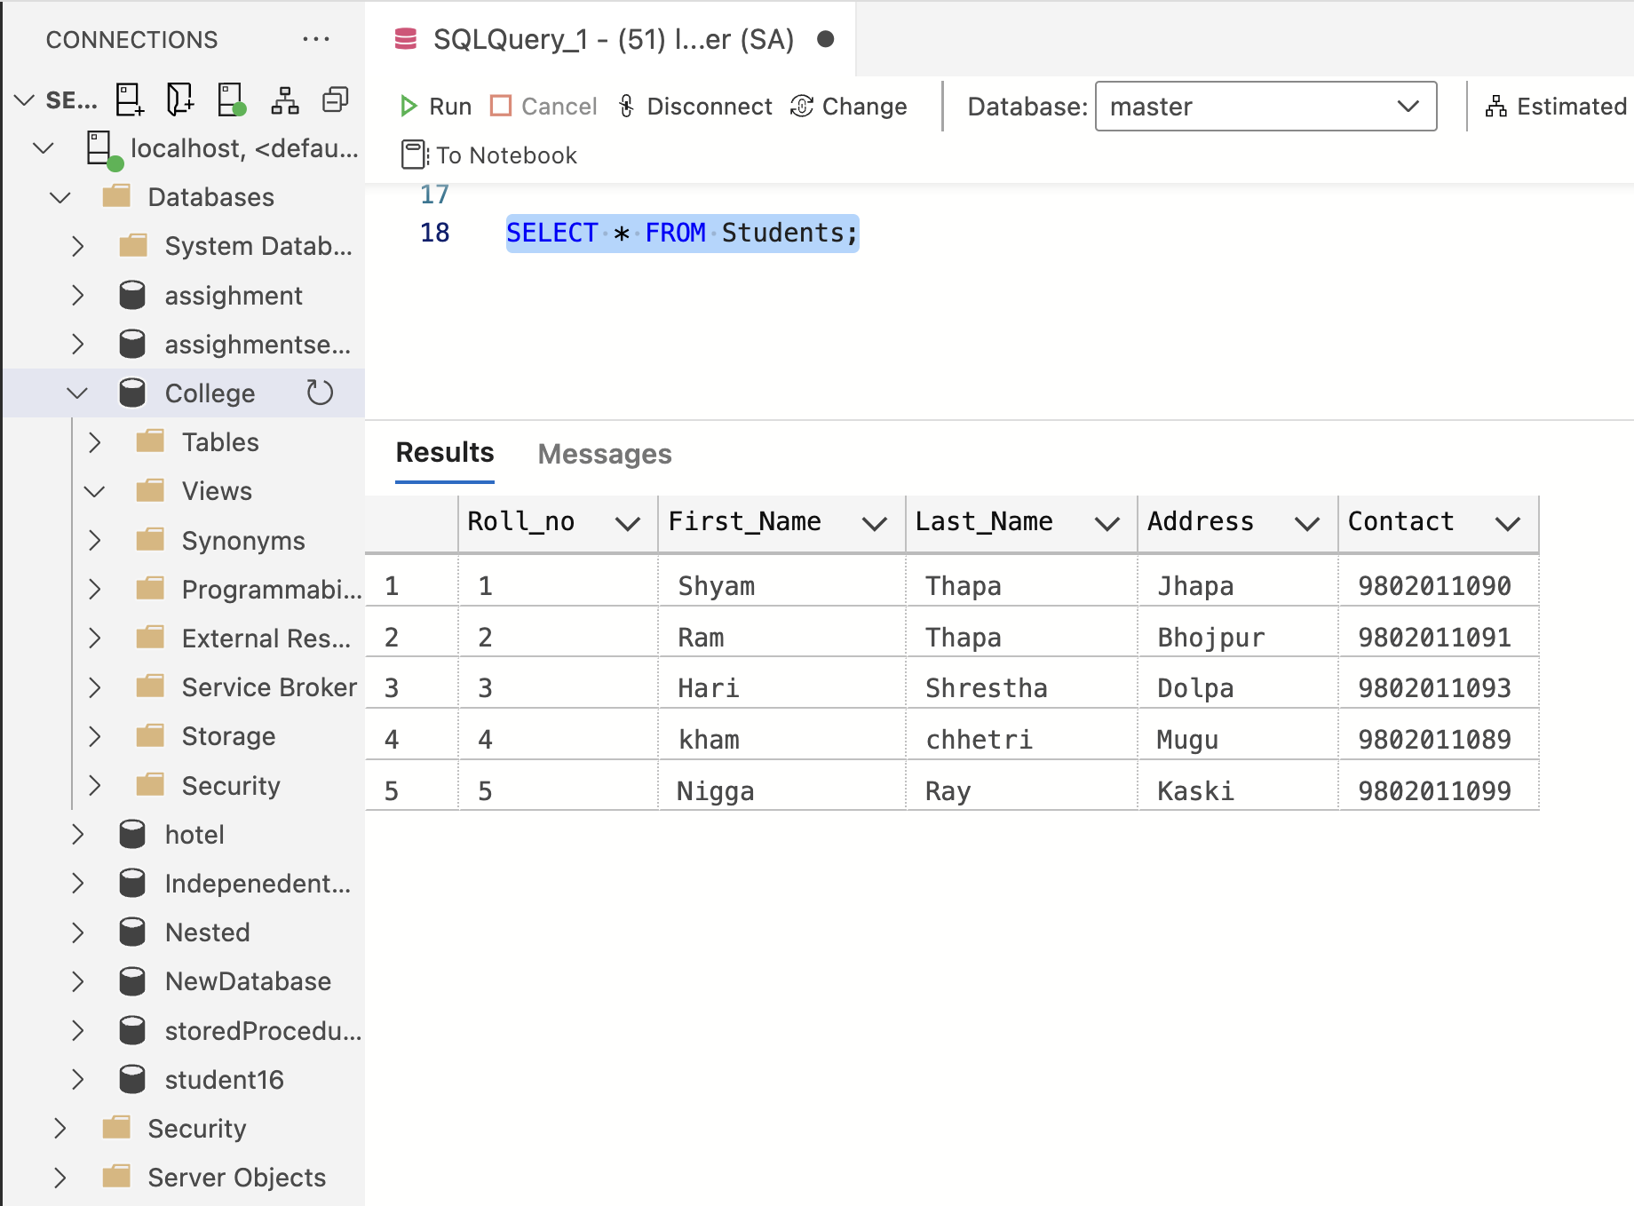

4.Display only roll number and student name from student table.

Solution:-

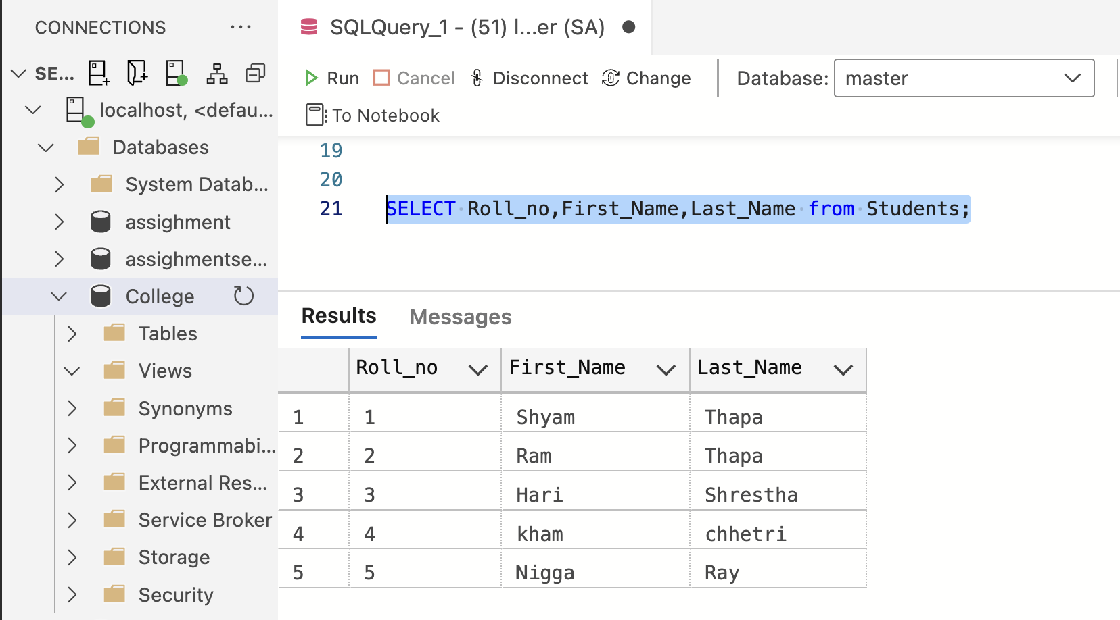

5.Display only those address whose address is jhapa.

Solution:-

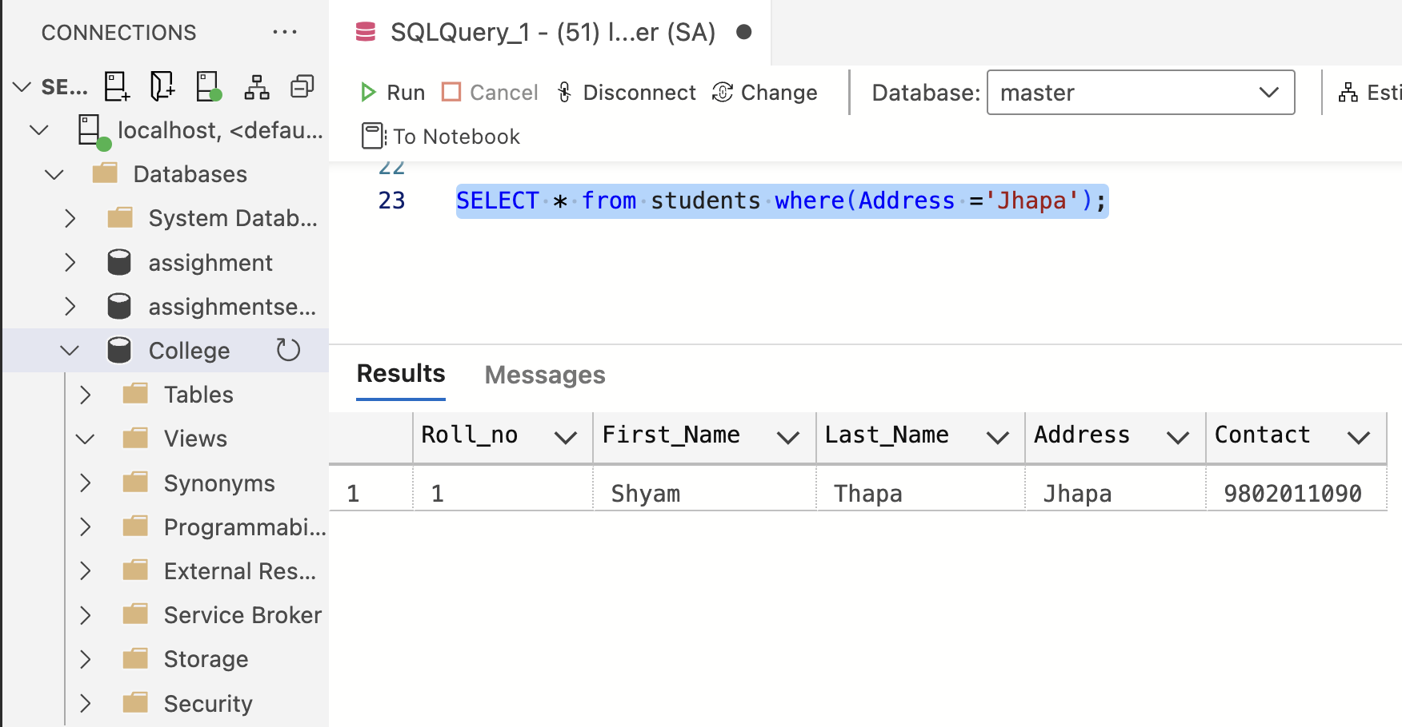

6.Modify address of those students whose roll no 1 to KTM and display table.

Solution:-

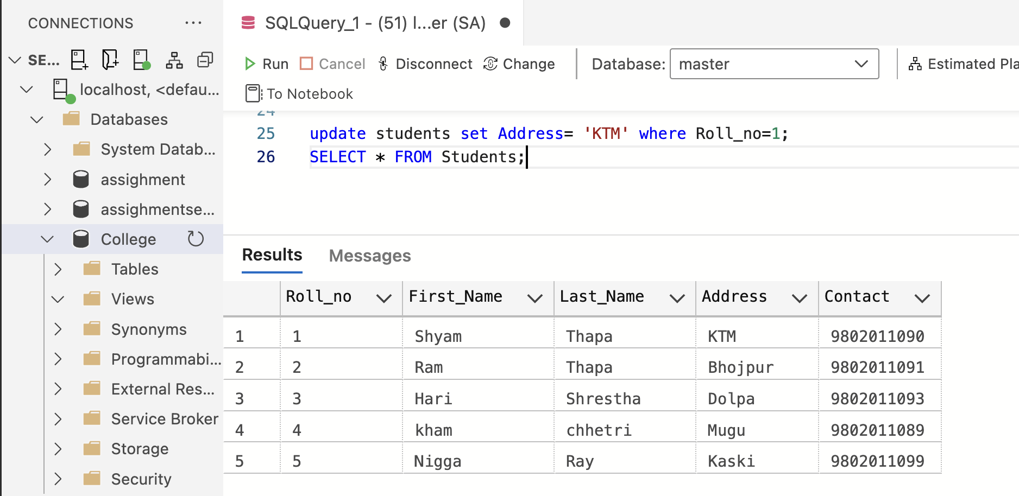

7.Altering table by adding new column email varchar(50)

Solution:-

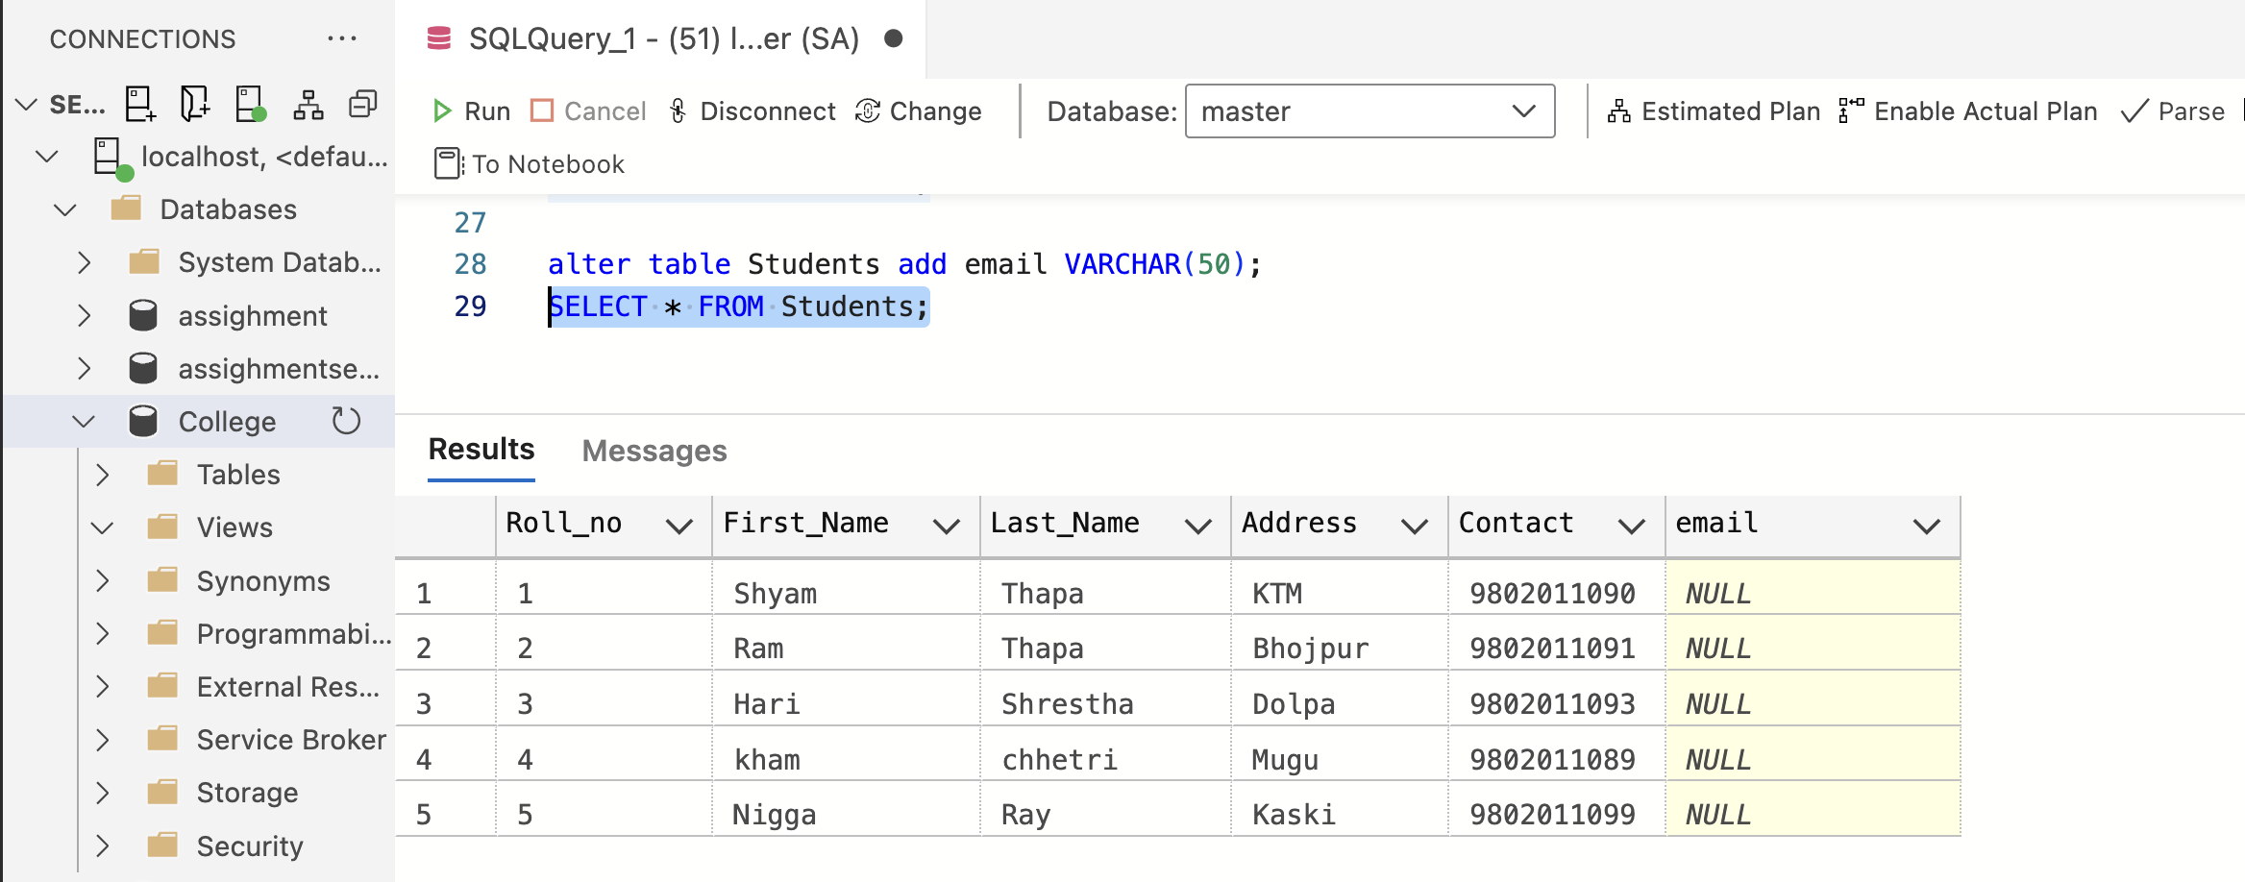

8.Deletes a rows from table where student roll is equal to 5.

Solution:-

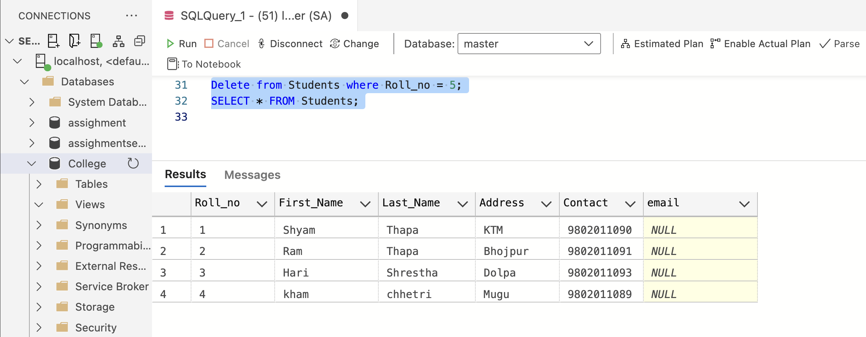

9.Drop a column contact from student table.

Solution:- 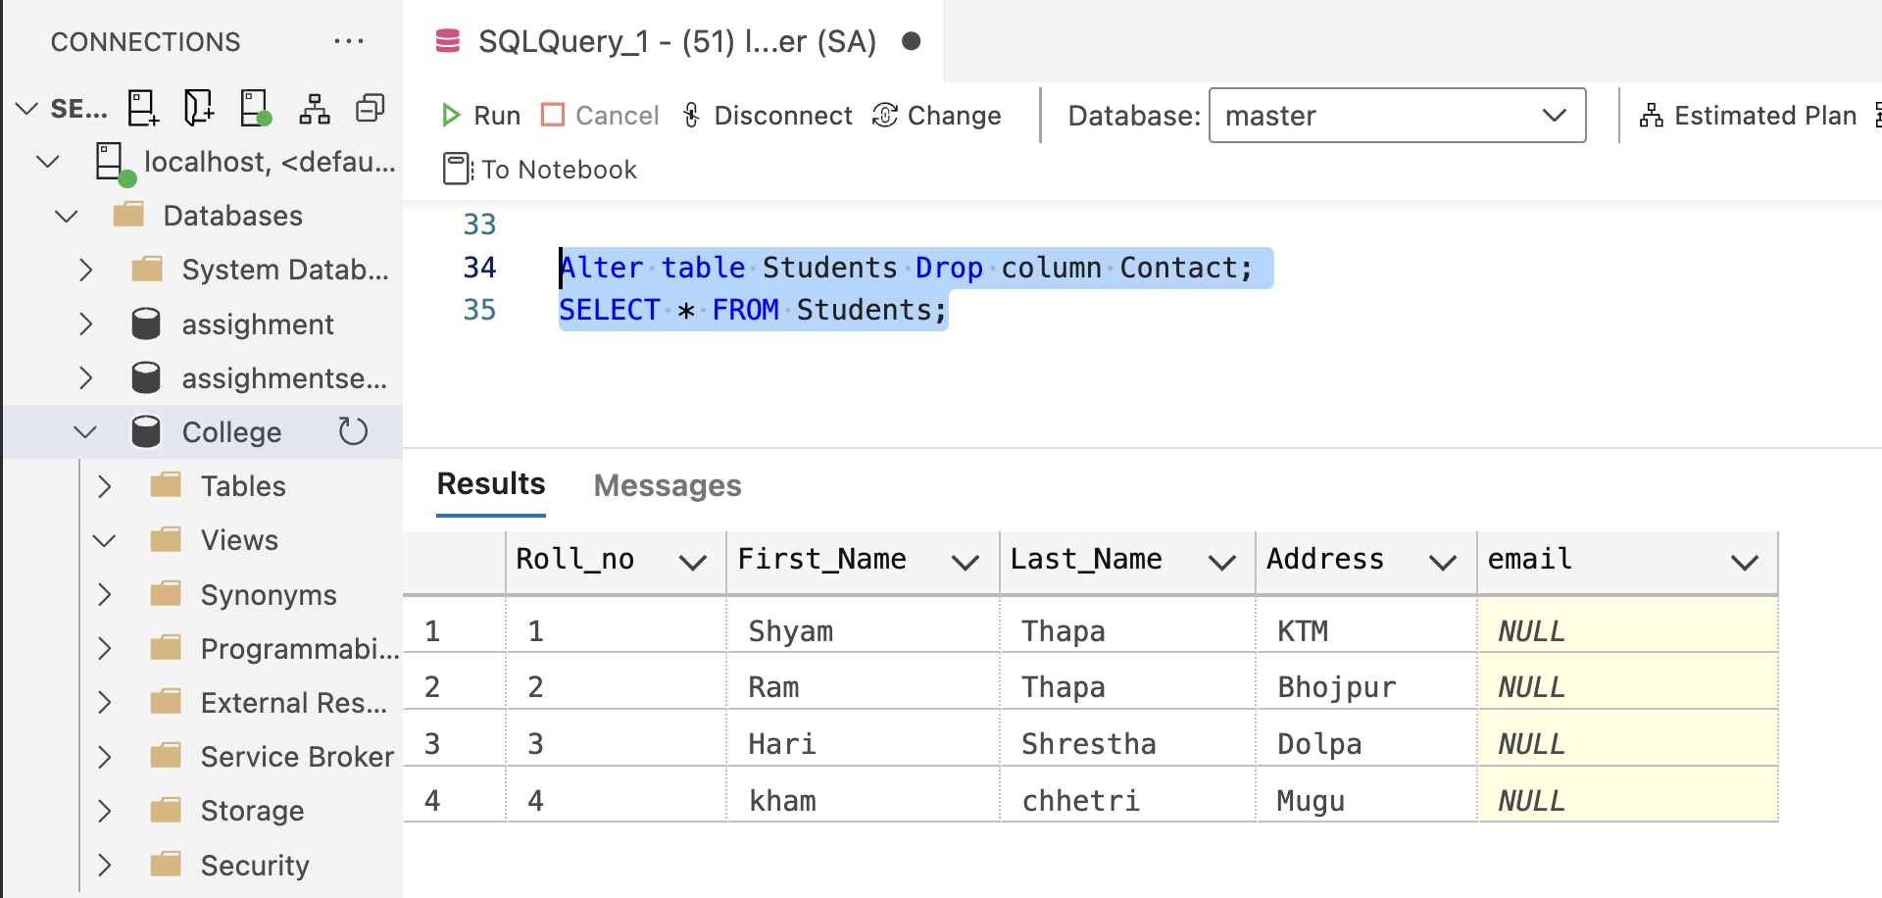

10.Delete those students whose roll number is less than 2 .

Solution:-

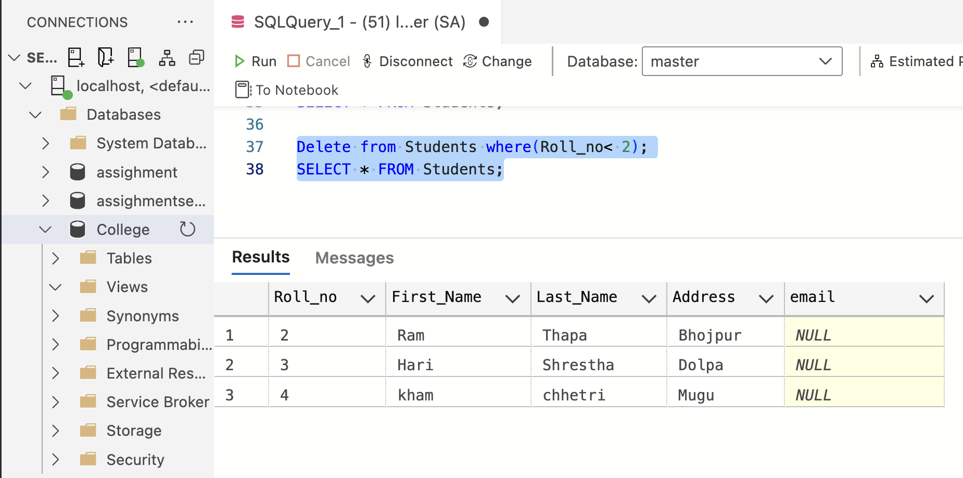

11.Alter table by changing the data type of name to varchar (20).

Solution:-

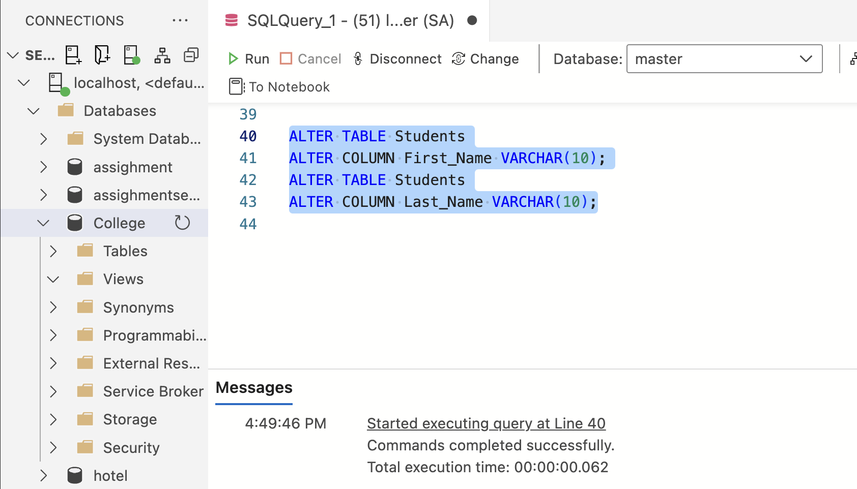

12.Delete all the data from the table student.

Solution:-

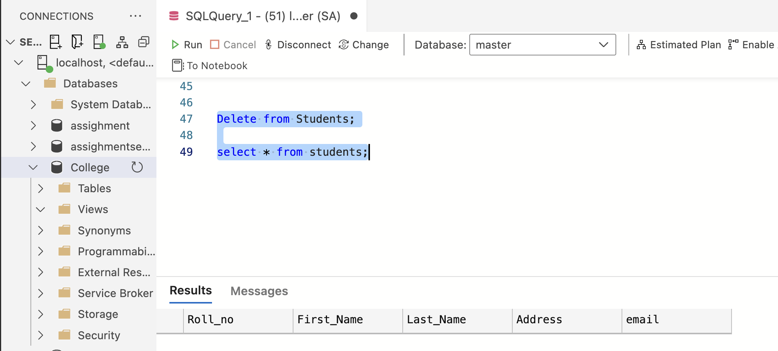

13.Delete entire table.

Solution:-

